Instructions

1. To use <https://aaga.andaman.gov.in>
2. To apply General Pool, Change to Same Type and Change to Higher Type application

General Pool

1. Click on Apply Online to General Pool

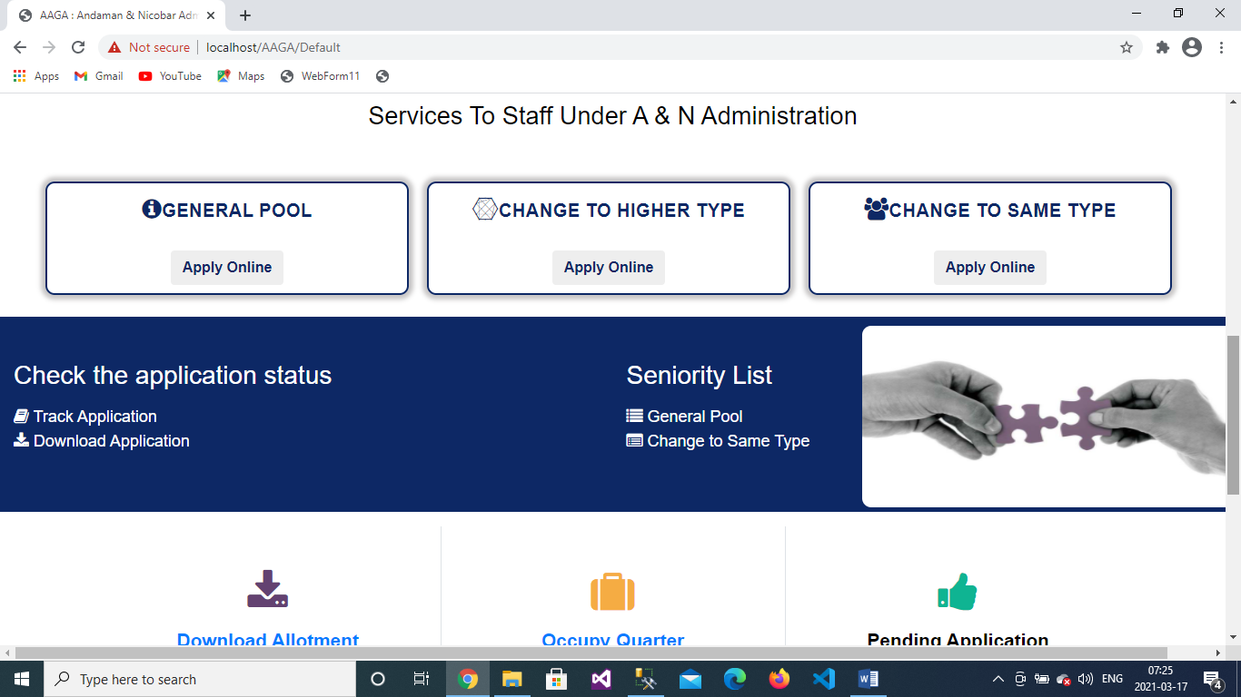

1. Personal Details - Enter Personal Details like name, father’s name, spouse’s name (if any), gender, date of birth, marital status, mobile number, PAN number, Aadhaar number, category, designation, email id (if any)

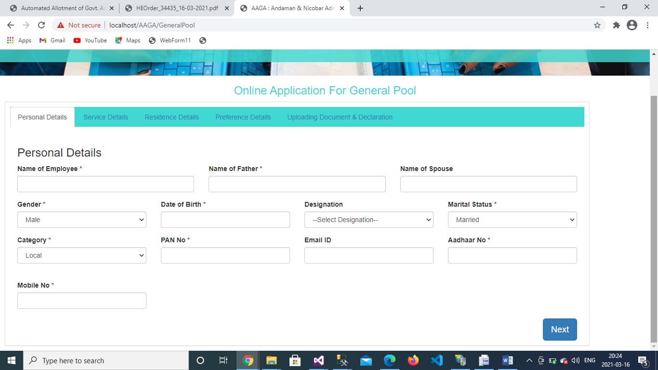

1. Service Details - Enter Service Details like Date of Superannuation/Retirement, Date of eligibility for allotment of type V and above (Priority Date), Date from which continously employed in govt. service, Date from which continously posted in the present city, GPF/PRAN Account No, Date of Present Pay Level continously drawing from, select Service to which Official/Officer belong, DDO Code, Present office, Sub Division, Pay Level, Present Pay, Group type.

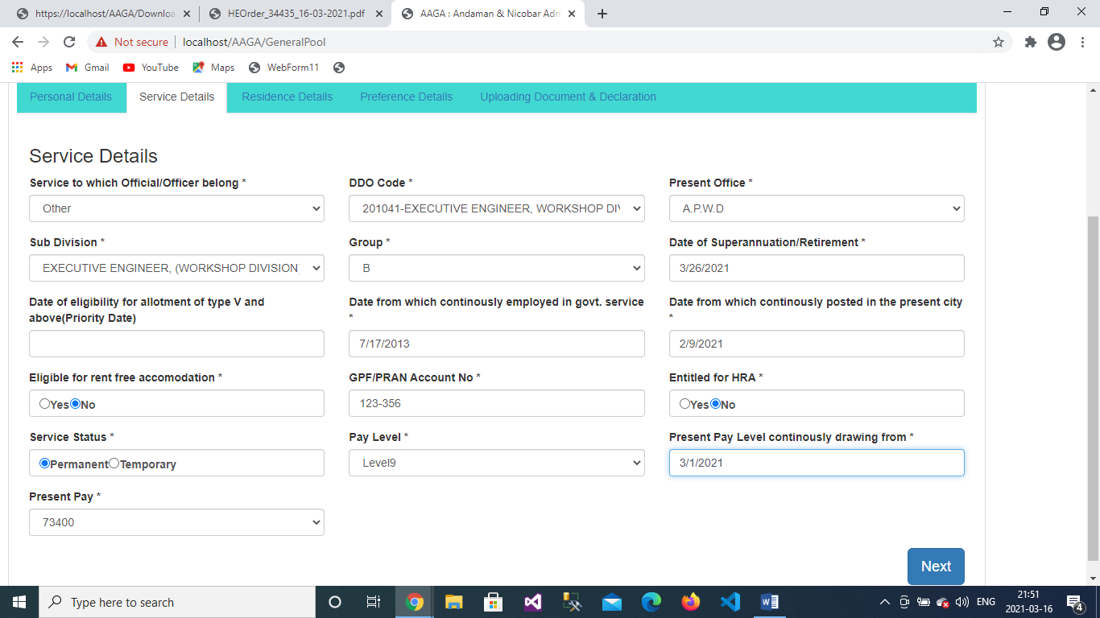

1. Residential Details - Enter residential details like present residential address, Sanctioned housing/building loan etc.

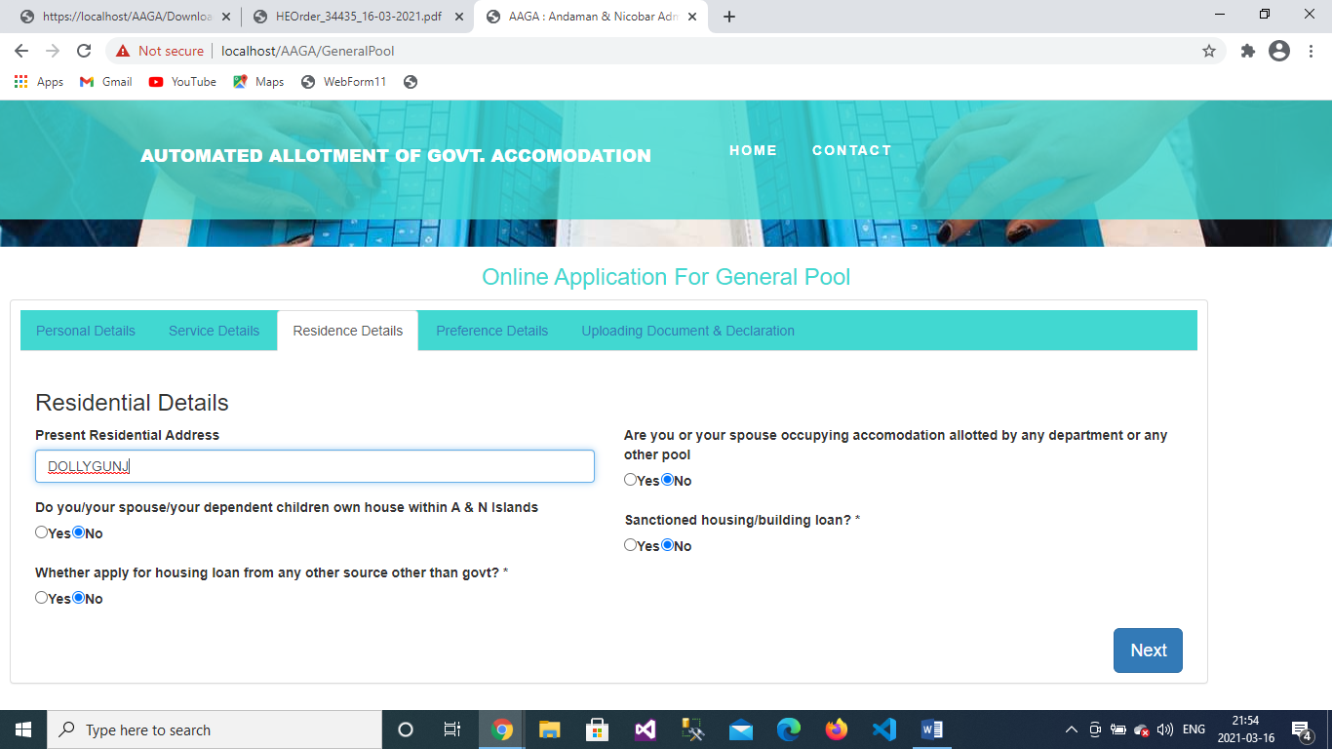

1. Preference Details- Choice of Preferred Location, Floor and Quater No, and whether apply on Medical ground or not.

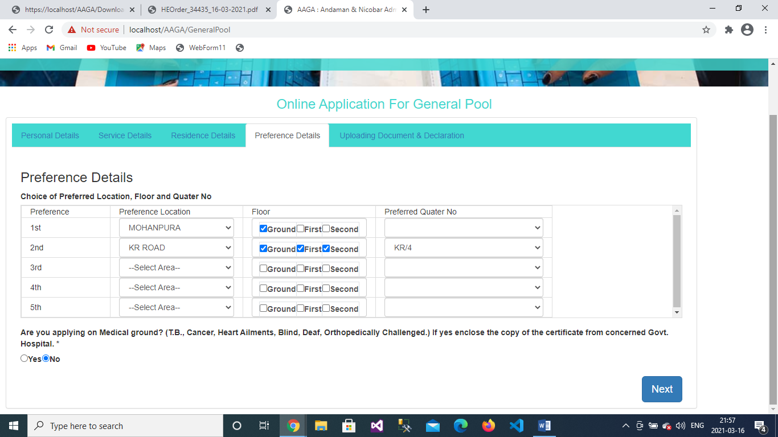

1. Uploading Document and Declaration- Upload photograph, signature, Copy of Appointment order, Pay Slip, and Medical Certificate if apply on Medical ground and enter order no, order date, and order type and declare the validation of your application, and at last the captcha.

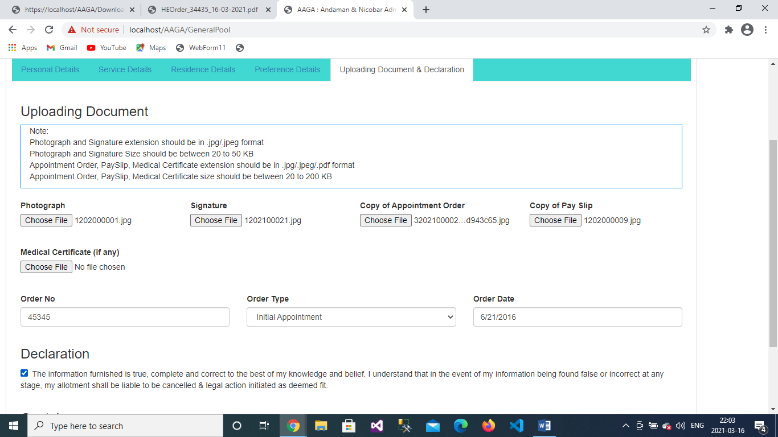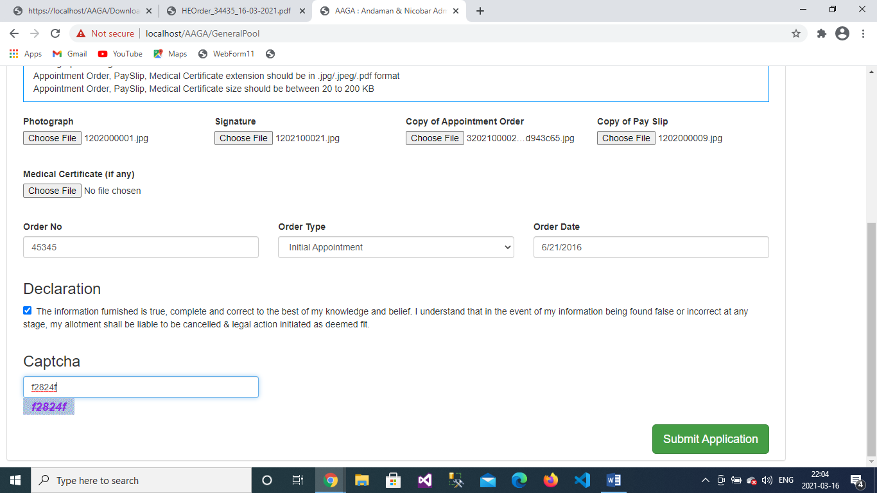

1. Click on “Submit Application” button.
2. Print the application acknowledgement

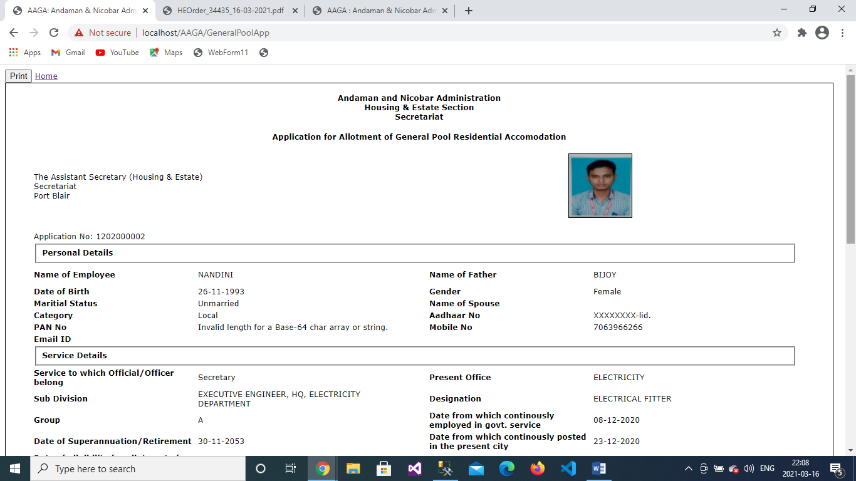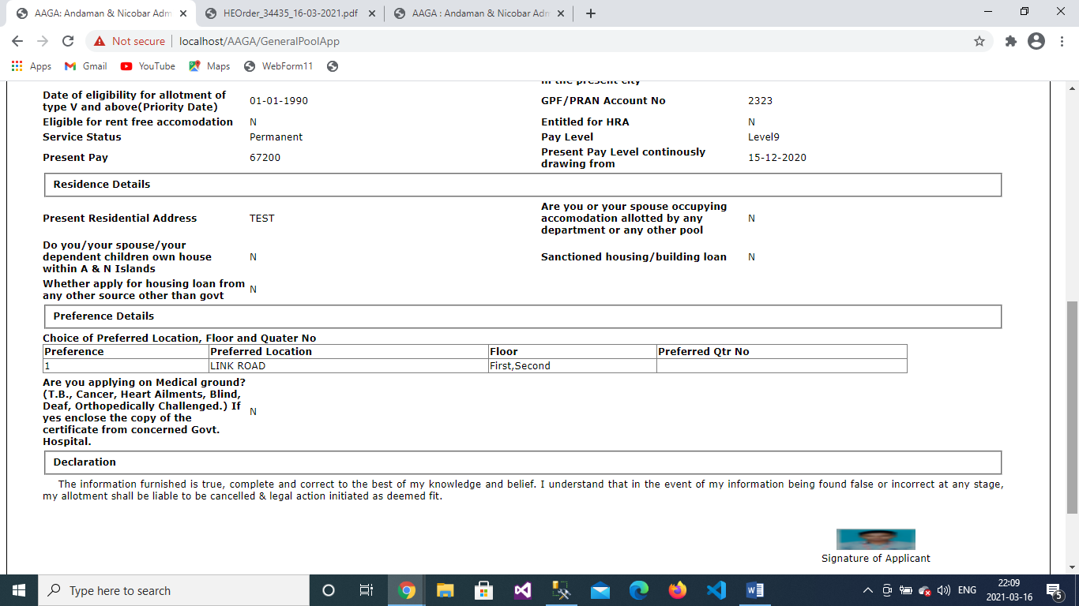

Change to Same Type

1. Click on Apply Online to Change to Same Type



1. Entered registered mobile number and captcha and click on Submit Button

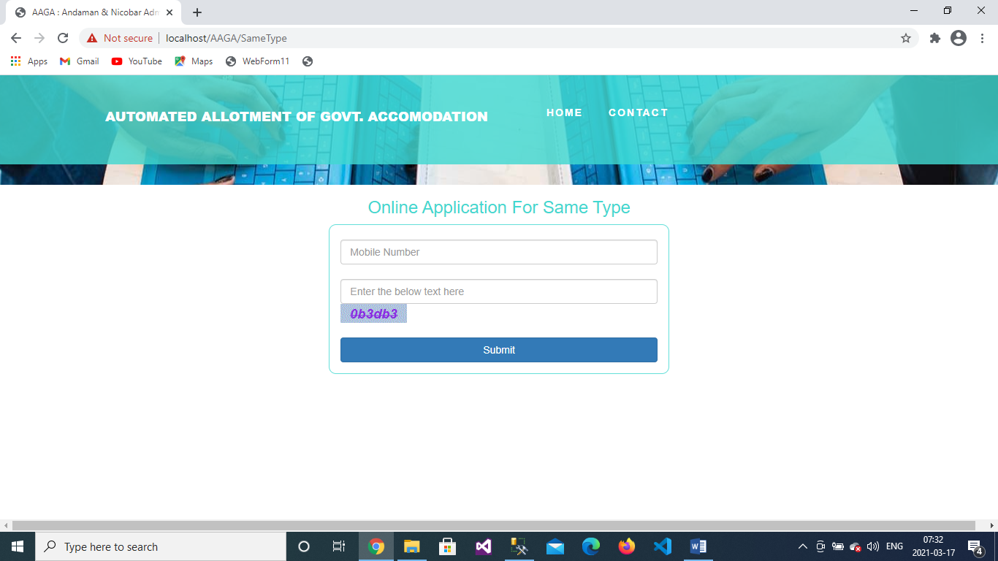

1. Enter the OTP which you received in your registered Mobile Number and click on “Verify OTP” button

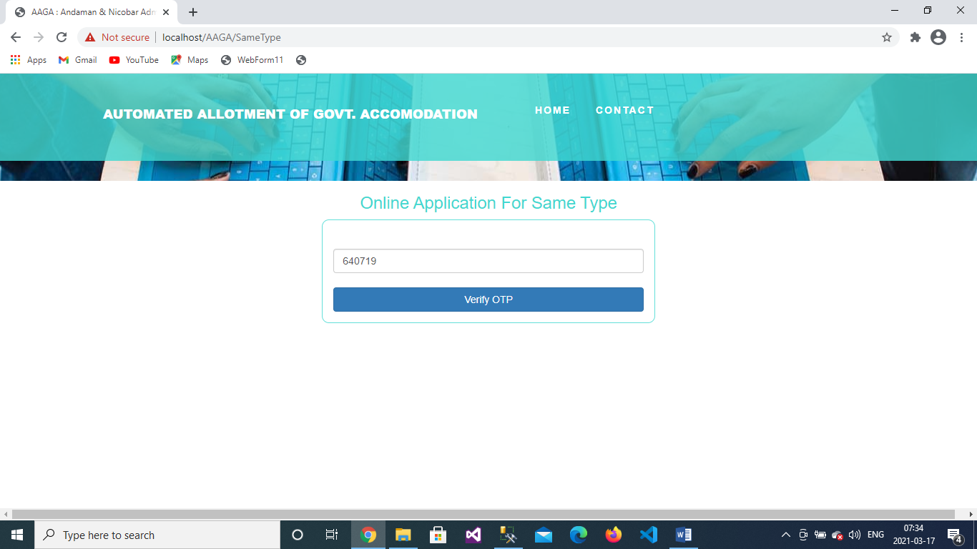

1. Select your allotted quarter area, type and quarter number then click on “Search” button.

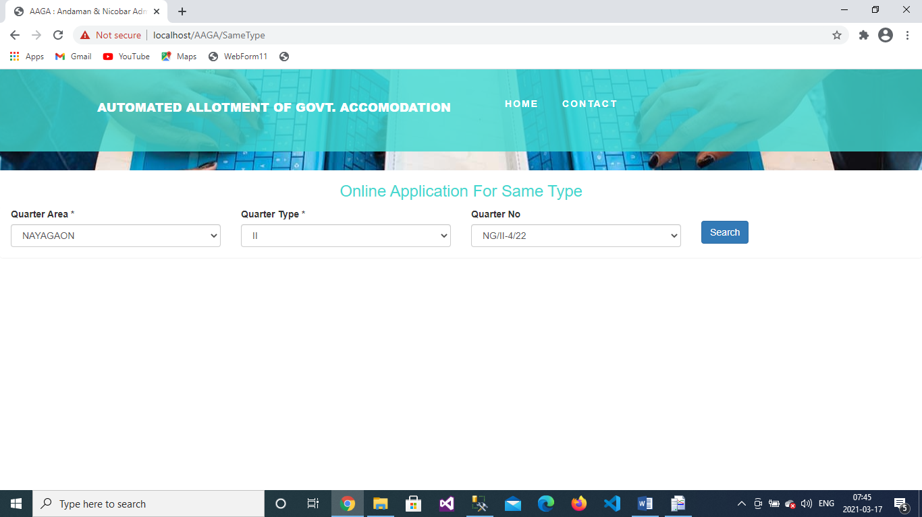

1. Personal Details: Enter your personal details which is not present

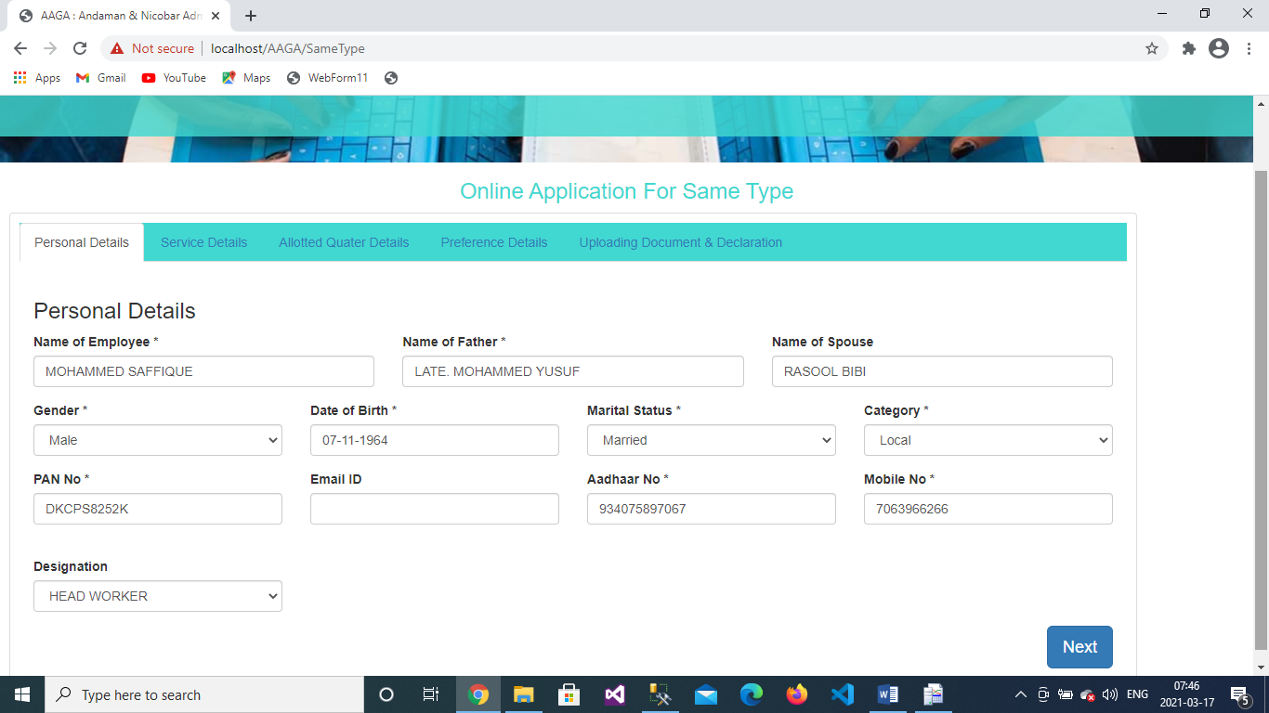

1. Service Details:

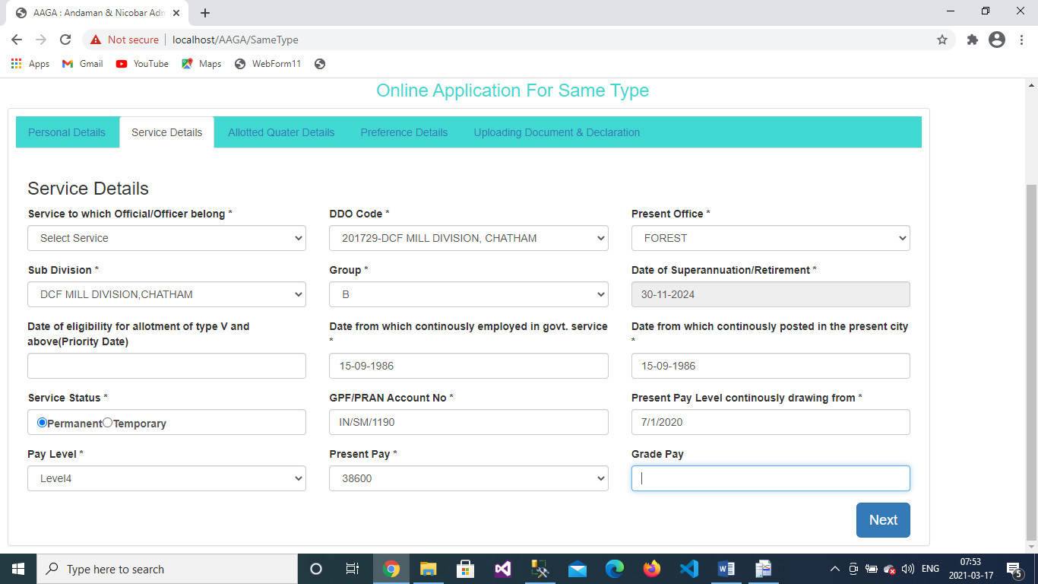

1. Allotted Quarter Details: Select reason of quarter change

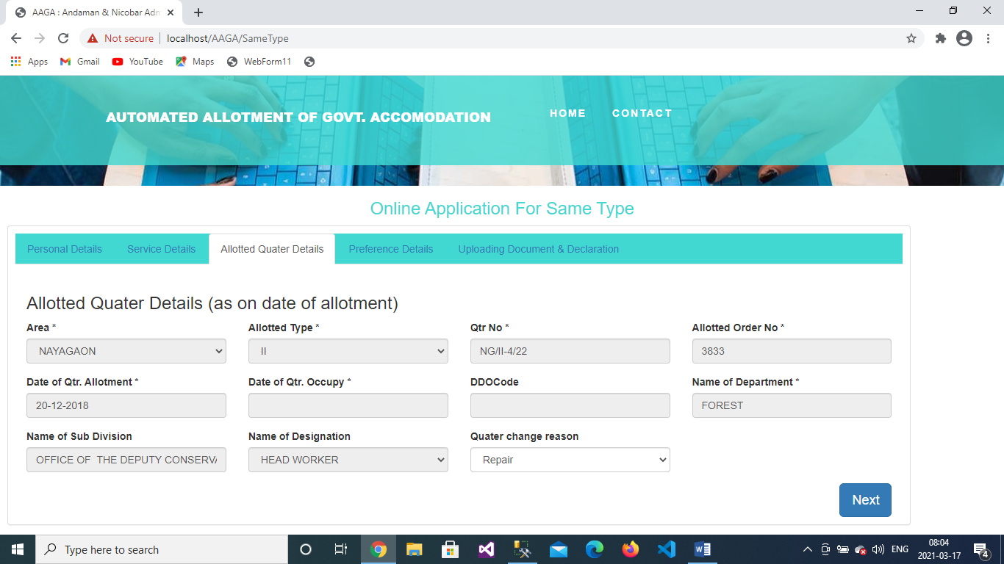

1. Preference Details: Choose preferred quarter location, floor, and quarter number and select **applying on Medical ground or not**

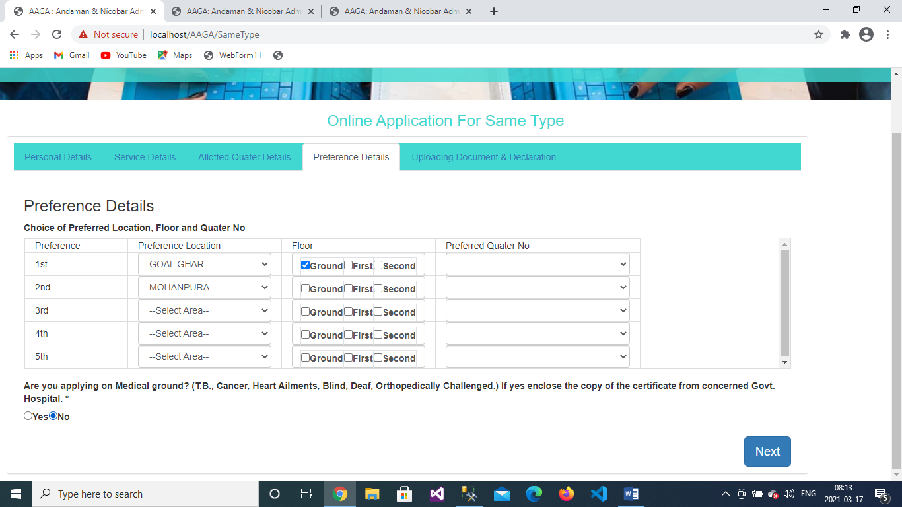

1. Uploading Document and Declaration: Upload Photograph, Signature, Copy of Appointment order, Copy of Quarter Allotment Order and Pay Slip, and enter the captcha and declare the validity of details you entered.

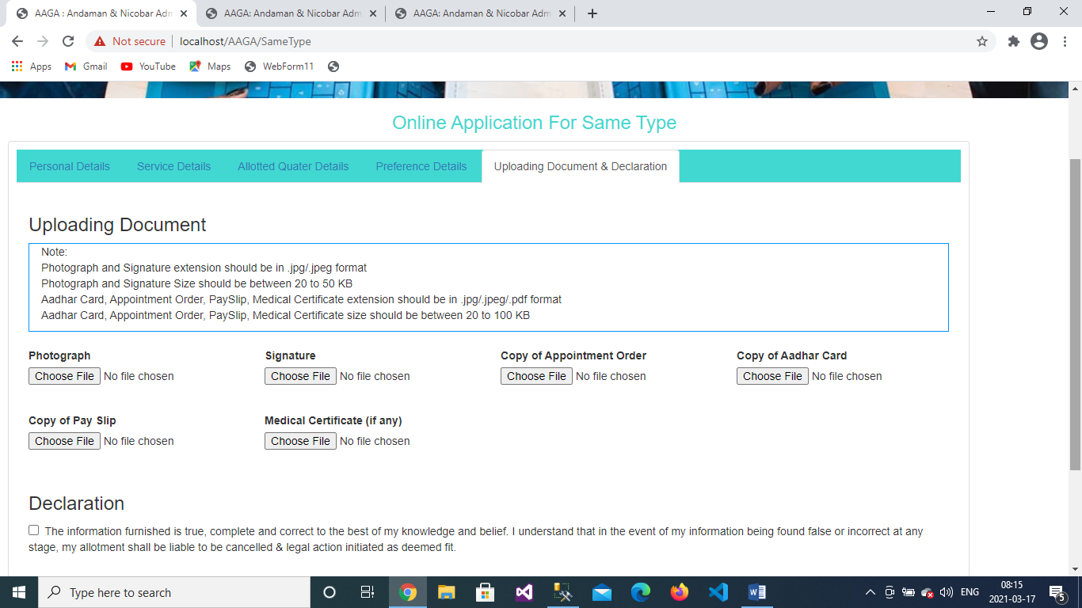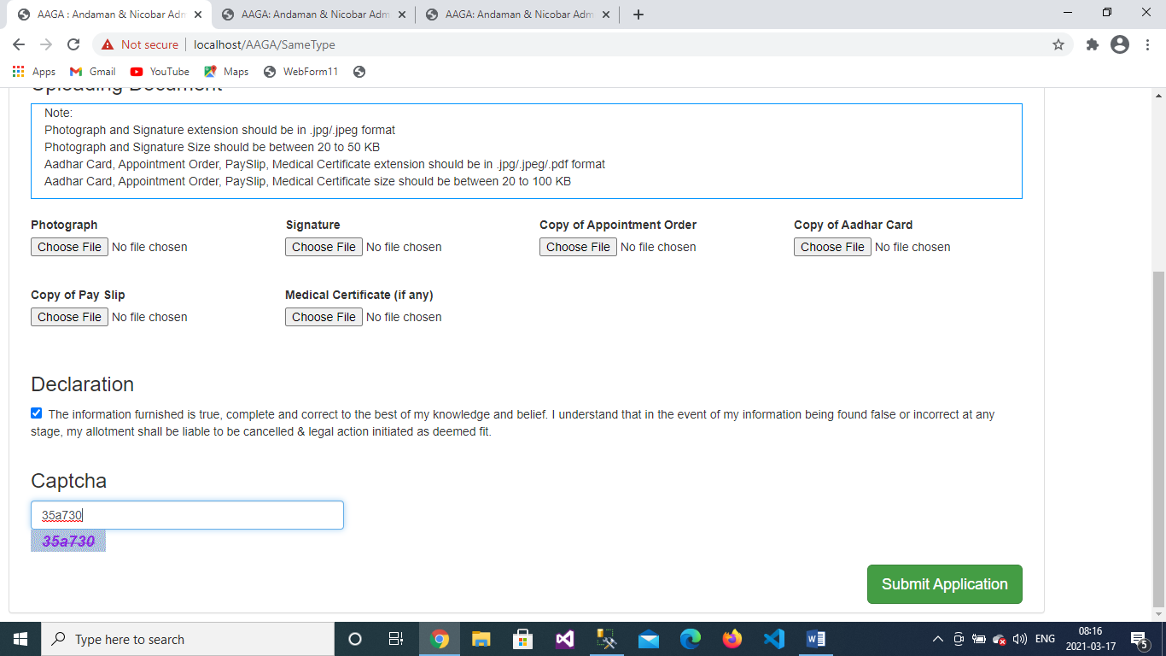

1. Click on “Submit Application” button.
2. Print the application acknowledgement

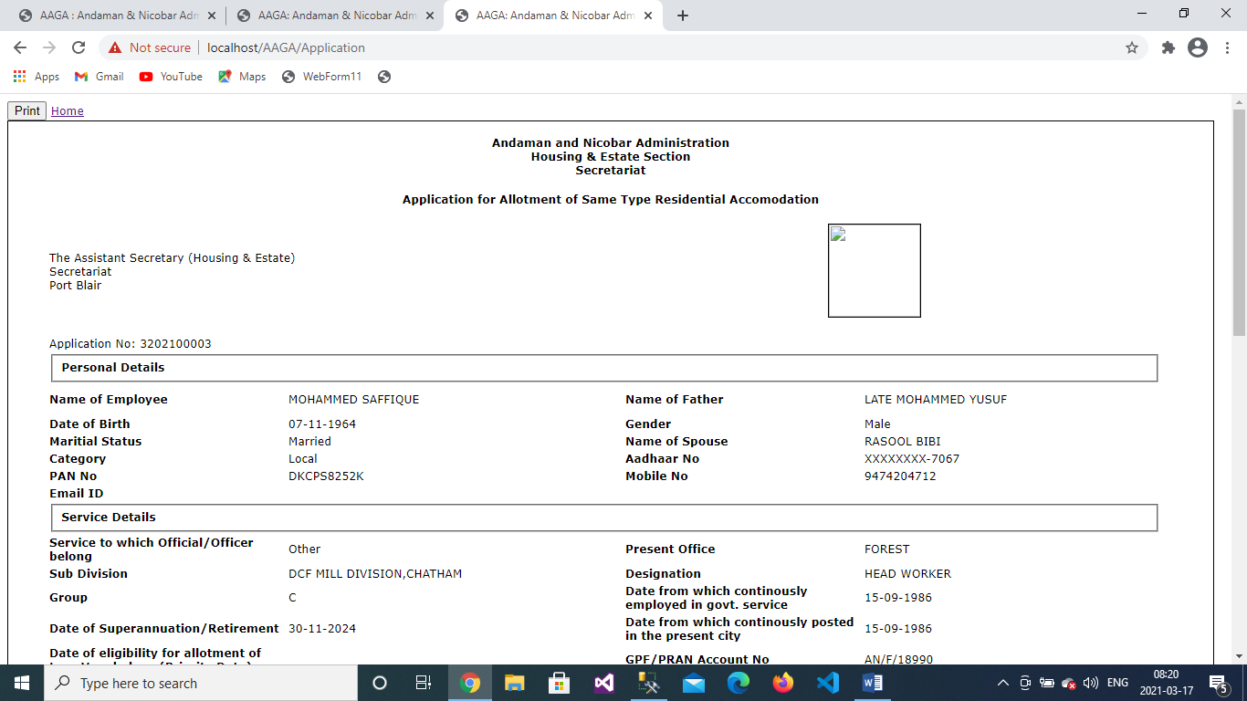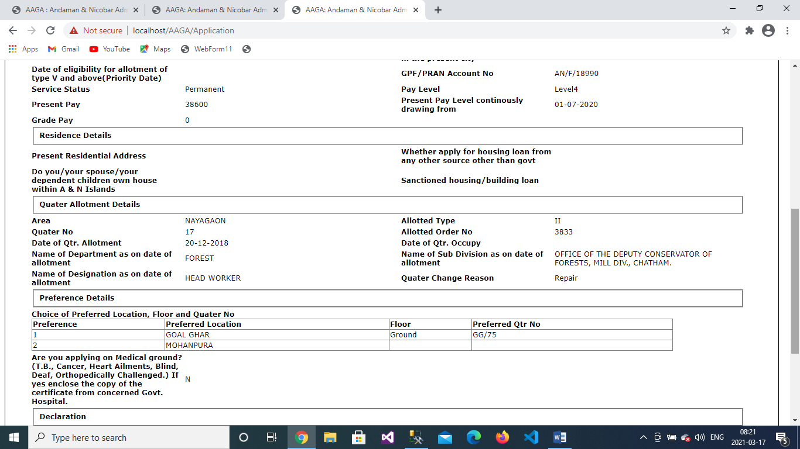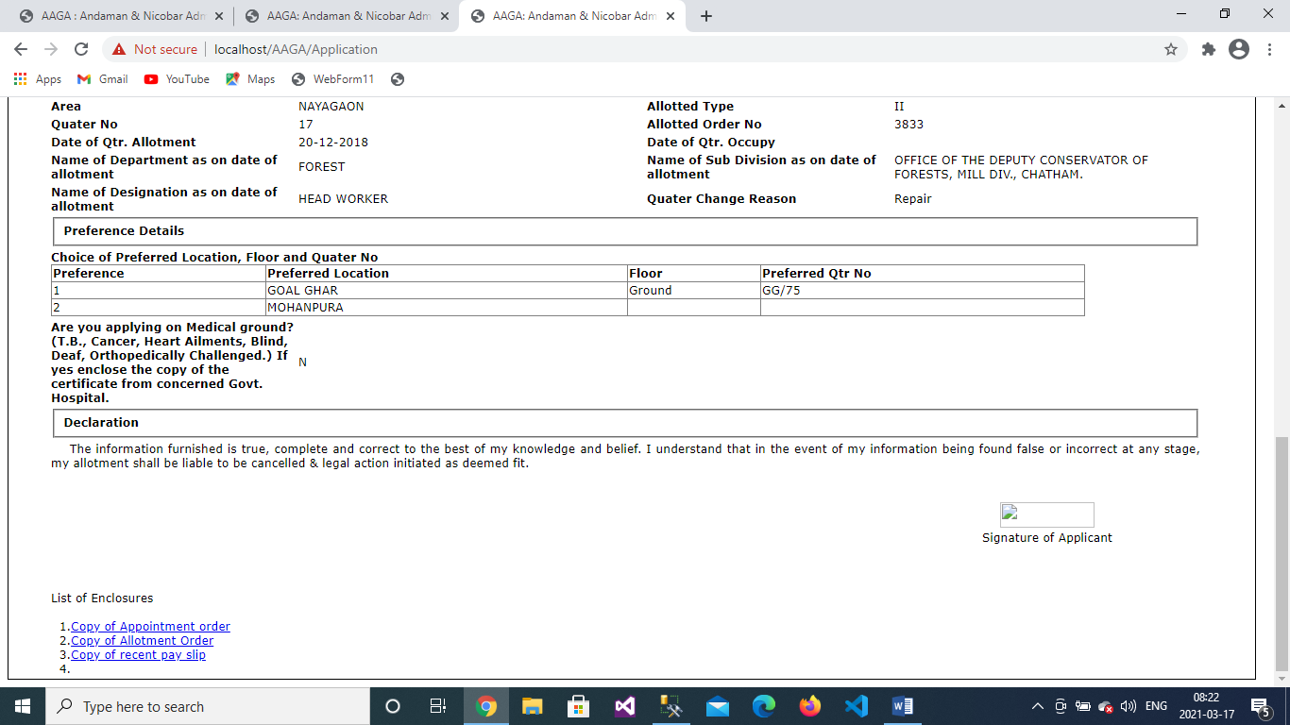

Change to High Type

1. Click on Apply Online to Change to Same Type



1. Entered registered mobile number and captcha and click on Submit Button

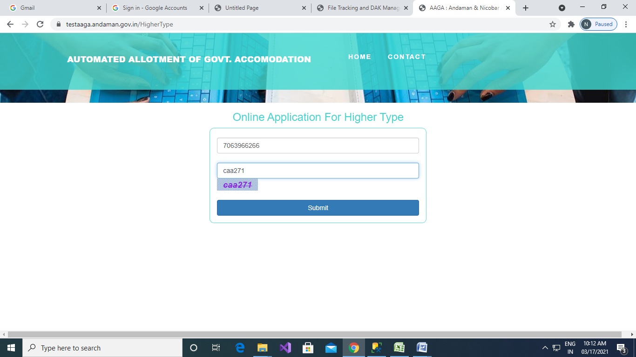

1. Enter the OTP which you received in your registered Mobile Number and click on “Verify OTP” button.

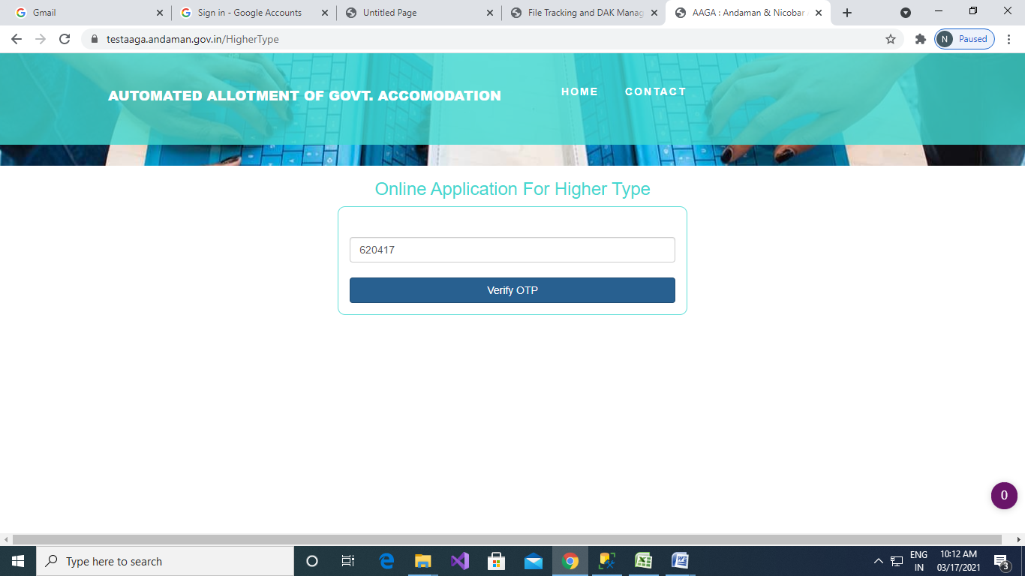

1. Select your allotted quarter area, type and quarter number then click on “Search” button.



1. Personal Details: Enter your personal details which is not present

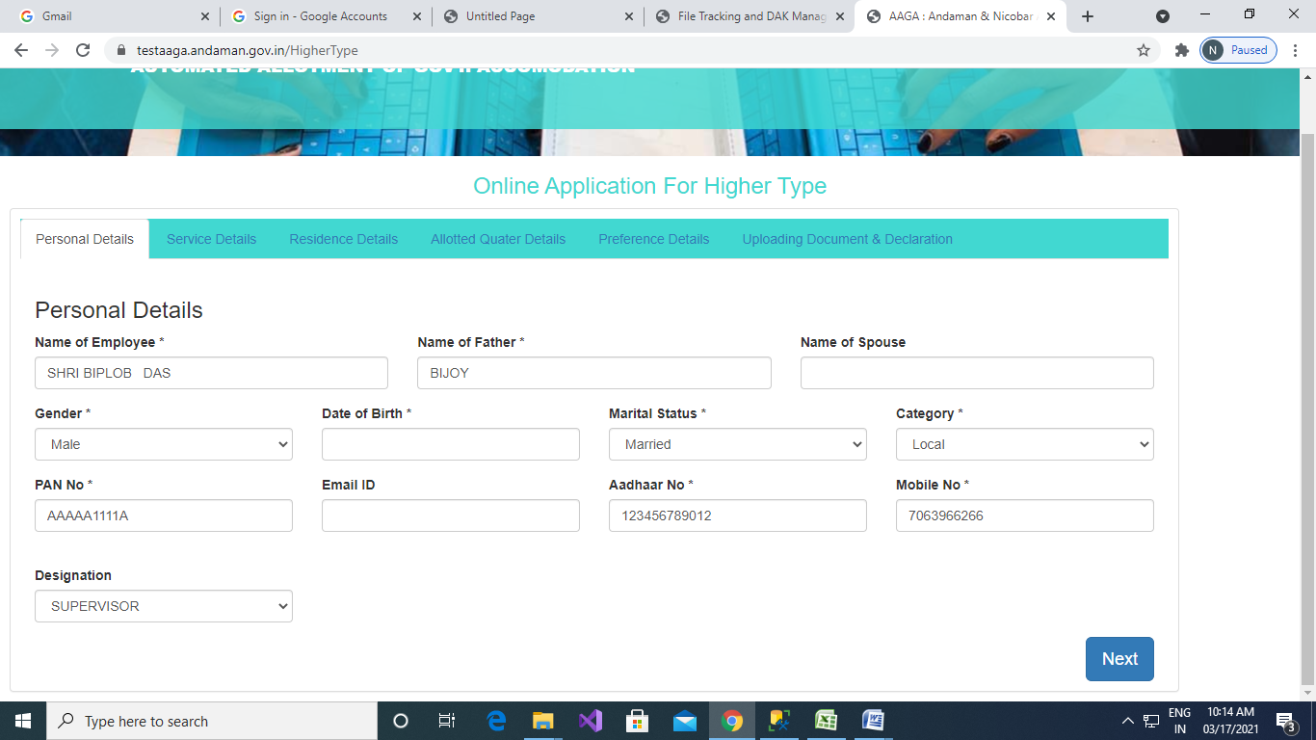

1. Service Details:

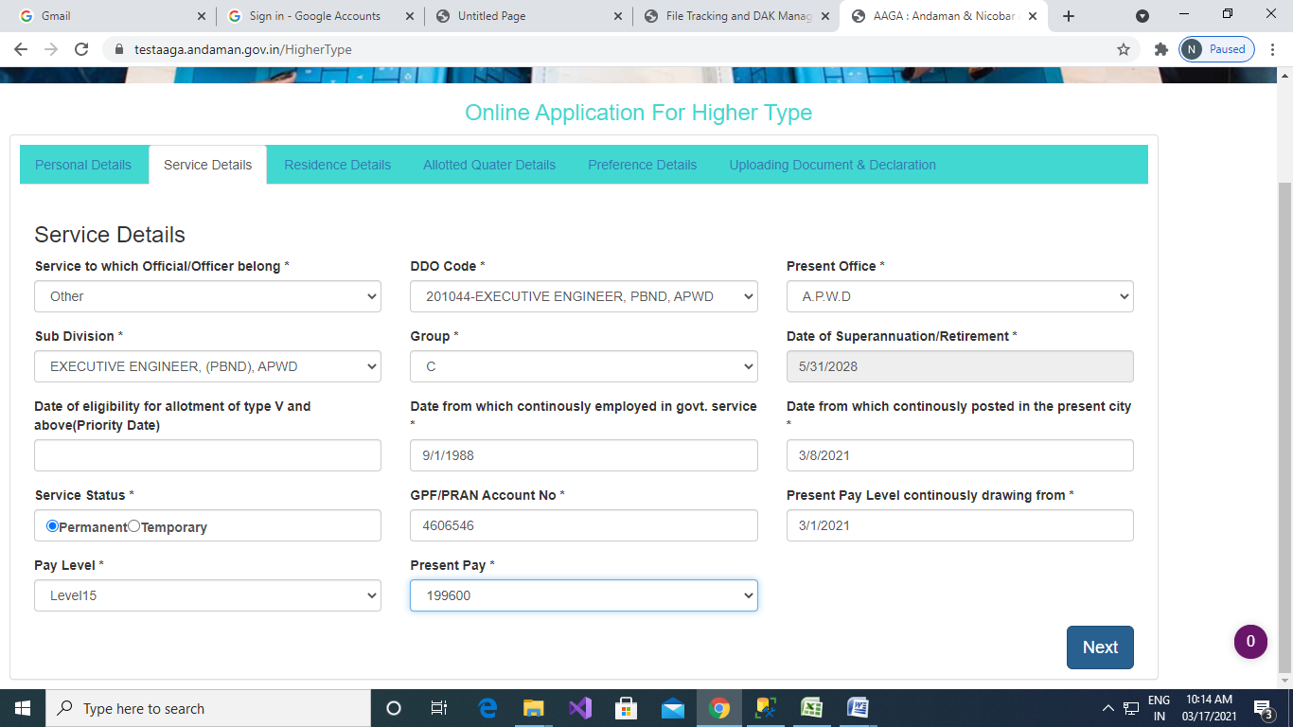

1. Allotted Quarter Details: Select reason of quarter change

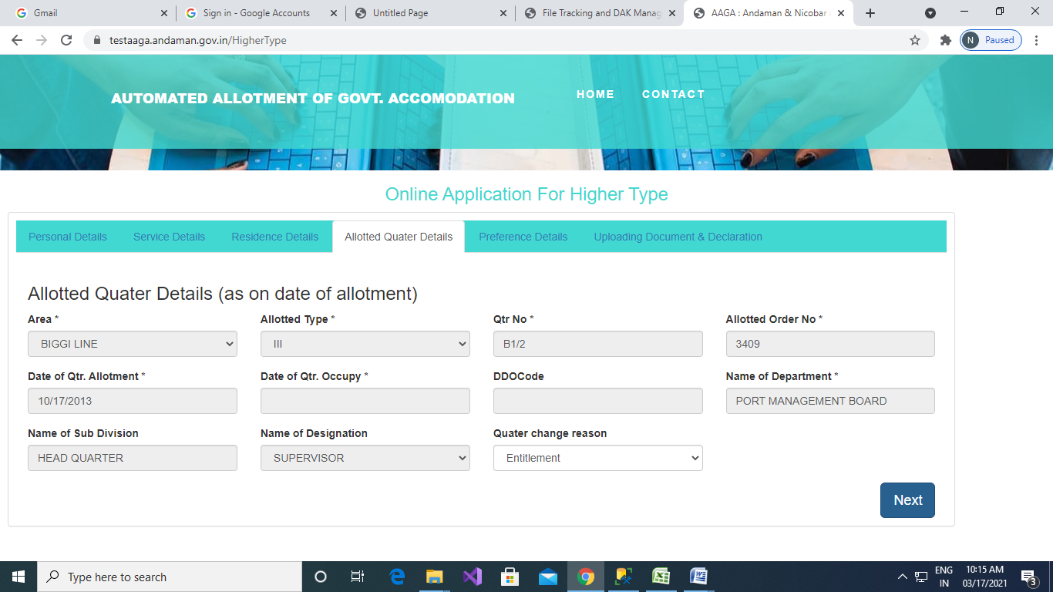

1. Preference Details: Choose preferred quarter location, floor, and quarter number and select **applying on Medical ground or not**

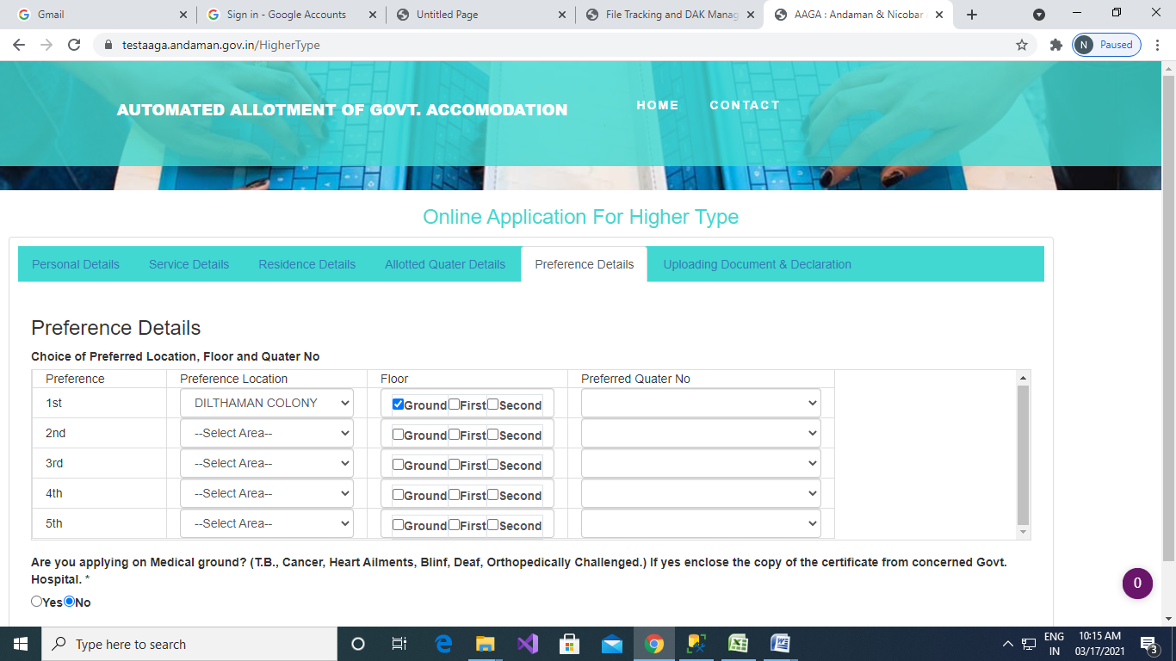

1. Uploading Document and Declaration: Upload Photograph, Signature, Copy of Appointment order, Copy of Quarter Allotment Order and Pay Slip, and enter the captcha and declare the validity of details you entered.

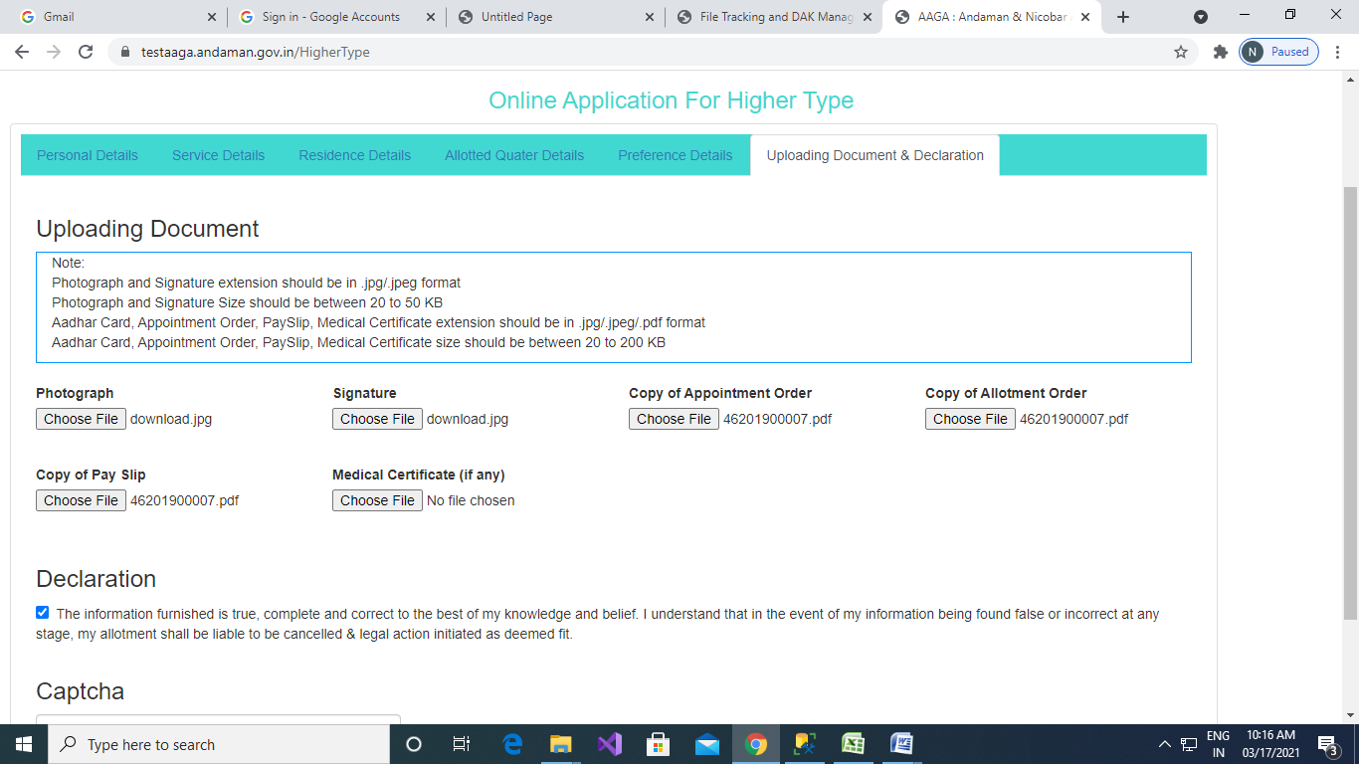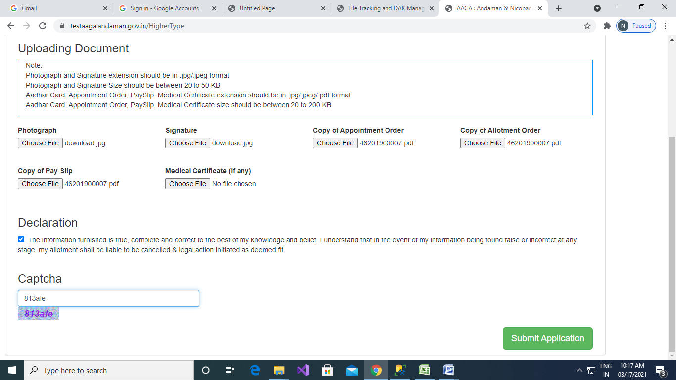

1. Click on “Submit Application” button.
2. Print the application acknowledgement

